**Task # 1:** Take two inputs and Subtract

**Code:**

IN

STO 98

IN

STO 99

LDA 98

SUB 99

OUT

HLT

**Output:**

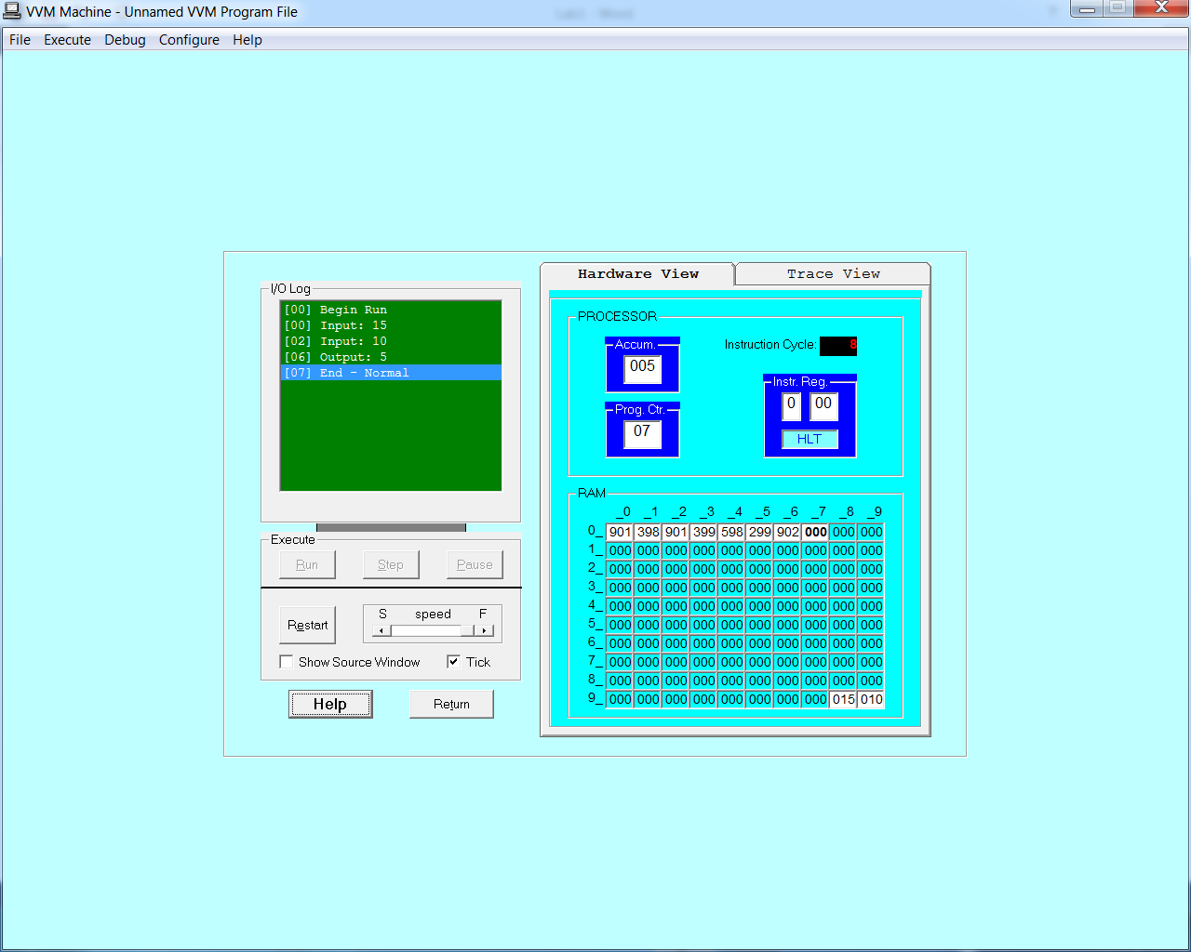

**Task # 2:** To take two hardcoded input and Add them.

**Code:**

LDA 98

ADD 99

OUT

HLT

*98

DAT 020

*99

DAT 010

**Output:**

